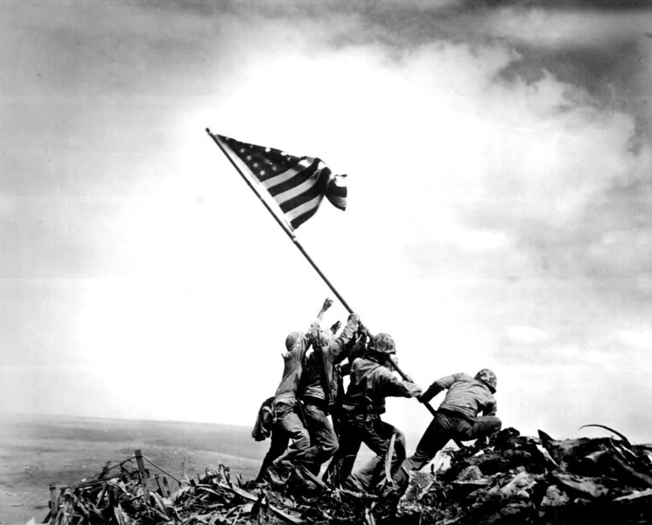
Things Worth Fighting For
II Samuel 23
Pastor Bobby Garvin
Remember the Price of Freedom (Galatians 5:1; John 15:13)

Honor those who fought for our Freedom (II Samuel 23:18)

Learn from their Example (Proverbs 27:17: I Corinthians 11:1-2)

Pray for those in Harm’s Way! (Psalms 144:5-7)

