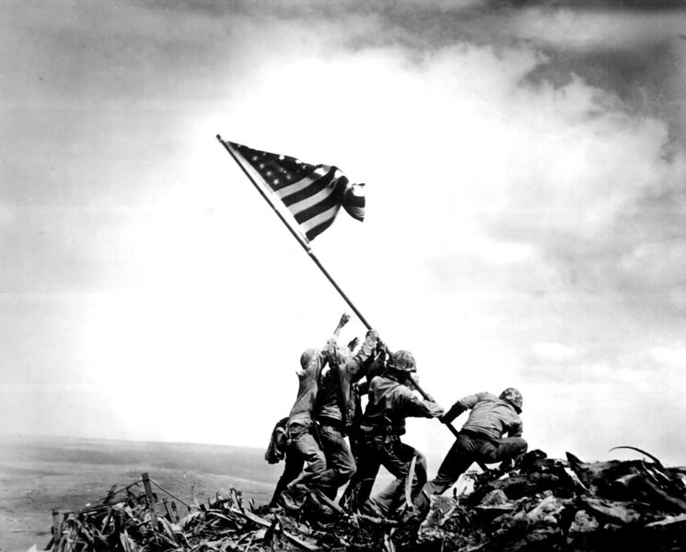
Things Worth Fighting For
II Samuel 23
Pastor Bobby Garvin
Remember the Price of __________ (Galatians 5:1; John 15:13)

________ those who fought for our Freedom (II Samuel 23:18)

Learn from their _________ (Proverbs 27:17: I Corinthians 11:1-2)

__________ for those in Harm’s Way! (Psalms 144:5-7)

